Teaching Experience
Regie's teaching experience includes being a classroom teacher (for most of the elementary grades), a reading specialist, a teacher of students with learning disabilities, a Reading Recovery teacher, a language arts resource and mentor teacher, a staff developer, and a literacy coach. Presently she works as a leader and mentor educator with districts and teachers dedicated to raising and sustaining reading and writing achievement, engagement, equity, and enjoyment for all learners--across the curriculum. Her books and resources are widely acclaimed as providing a solid, research-based understanding of language learning along with a wealth of practical ideas and extensive, annotated resources. Because Regie writes in an honest, personal, and encouraging voice based on her ongoing experiences in classrooms, schools and districts, teachers, principals, coaches, and administrators find her books and ideas are easy to read, understand, and apply to their own teaching, coaching, learning, and leading.
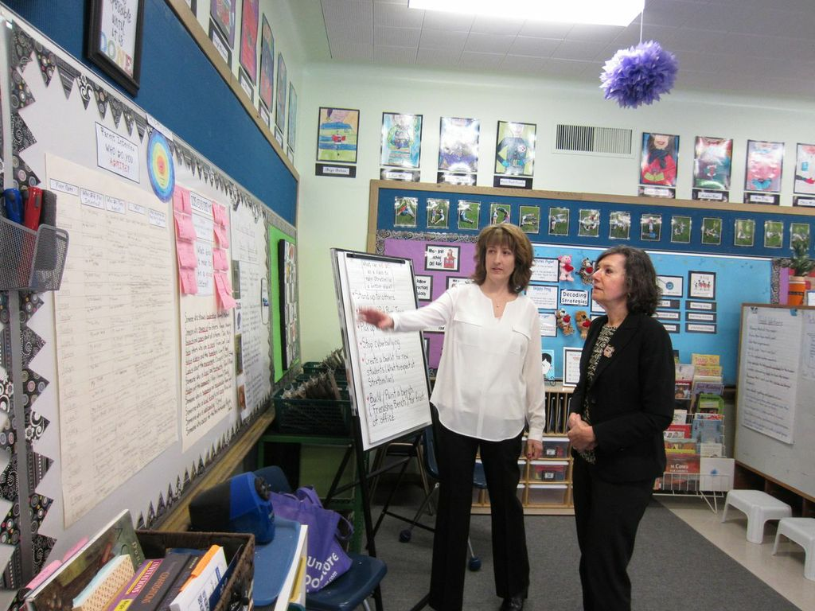
Regie lives in Seattle, Washington, with her husband, Frank. When not working, she loves going to local farmers’ markets, cooking, baking, making jams and fruit tarts, gardening, walking, reading fiction and nonfiction, traveling, spending time with friends, and fussing over her husband and two granddaughters. She is a daily devotee of the New York Times and especially savors the "Sunday Book Review."
